Saira Kousar

55503-BSCS-04

WAD LAB # O5

Tasks

Ma’am Nayyab Khalid

**Task # 01**

let bigNumber = BigInt(1234567890123456789012345678901234567890);

console.log("Type of bigNumber:", typeof bigNumber);

let uniqueId = Symbol("id");

console.log("Type of uniqueId:", typeof uniqueId);

**output:**

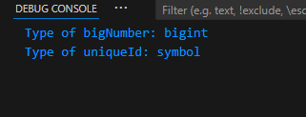

**Task # 02**

const product = {

    name: " PakWheels Waterless & Glass Cleaner",

    Sales: " Wheel Engine Sale ",

    discount: "20%" ,

    beforePrice: 1100,

    afterPrice: 958,

    items : [

       { name:"Glass Cleaner ",

        type:" Spray Bottle"

       },

       {

        name:"Waterless Car Wash ",

        type:" Spray Bottle"

       }

    ],

    orderNow: true

};

console.log(product);

**output:**

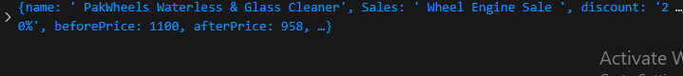

**Task # 03**

// Define the InstagramProfile object

class InstagramProfile {

    constructor(username, name, posts, followers, following) {

        this.username = username;

        this.name = name;

        this.posts = posts;

        this.followers = followers;

        this.following = following;

    }

    // Method to display profile details

    displayProfile() {

        console.log("Username:", this.username);

        console.log("Name:", this.name);

        console.log("Posts:", this.posts);

        console.log("Followers:", this.followers);

        console.log("Following:", this.following);

    }

}

// Creating an object for your profile

const user = new InstagramProfile("saira_kousar3", "Saira Kousar✨", 0, 66, 74);

// Displaying profile information

user.displayProfile();

**output:**

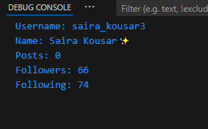

**Task # 04**

// Unary operators example

let x = 5;

console.log(x++);

console.log(++x);

console.log(x--);

console.log(--x);

**output:**

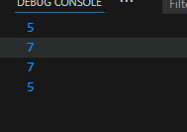

**Task # 05**

let number = prompt("Enter a number:");

if (number % 3 === 0) {

    console.log("Multiple of 3");

} else {

    console.log("Not a multiple of 3");

}

**Output:**



Task # 06

let studentScore = prompt("Enter the student score:");

if (studentScore >= 80) {

    console.log("Grade: A");

} else if (studentScore >= 70) {

    console.log("Grade: B");

} else if (studentScore >= 60) {

    console.log("Grade: C");

} else if (studentScore >= 50) {

    console.log("Grade: D");

} else {

    console.log("Grade: F");

}

**Output:**

